After you log in to USOS platform, choose the tab “student exchange”

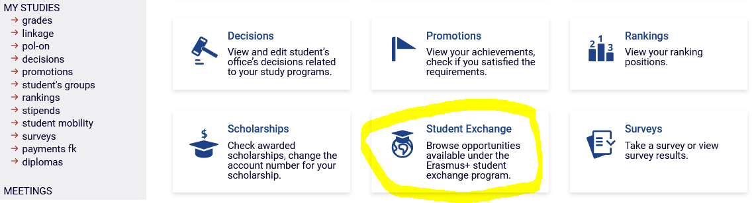

Here you can check the list of available universities

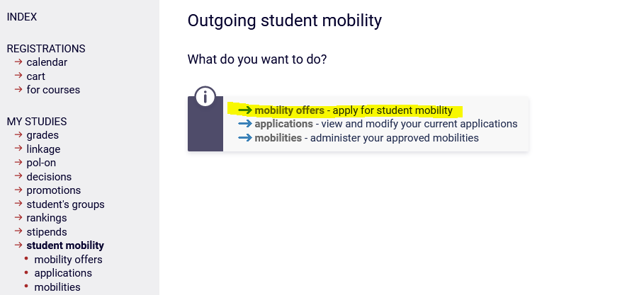

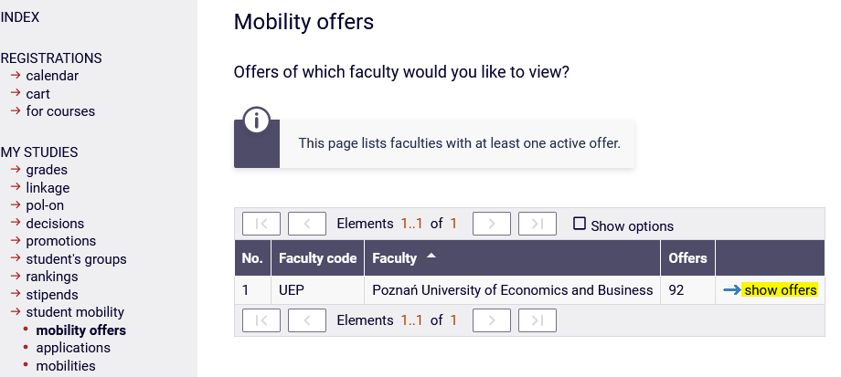

You can choose up to four universities from the list.

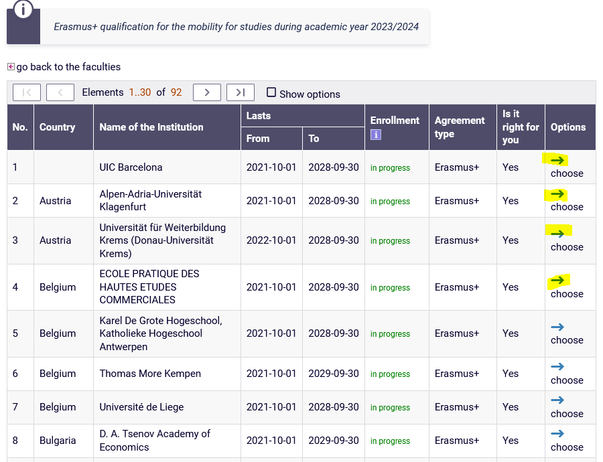

Choose new application and then edit.

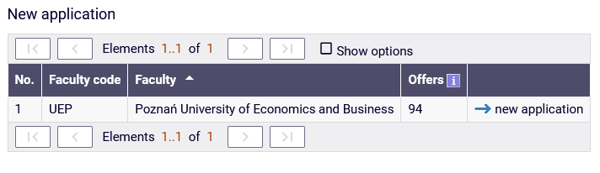

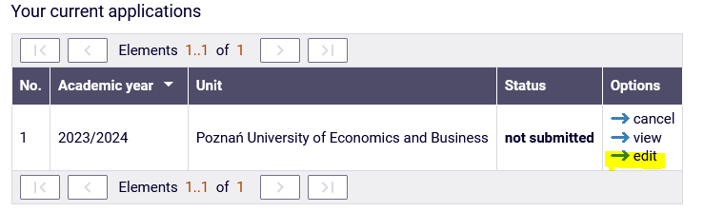

Add your choices

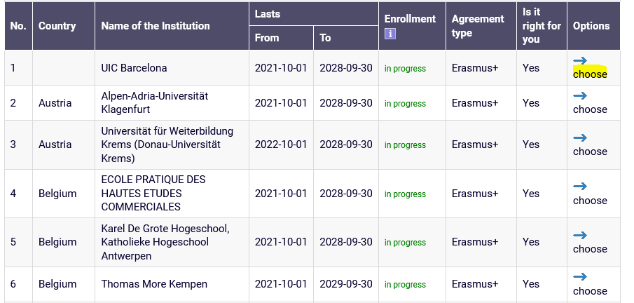

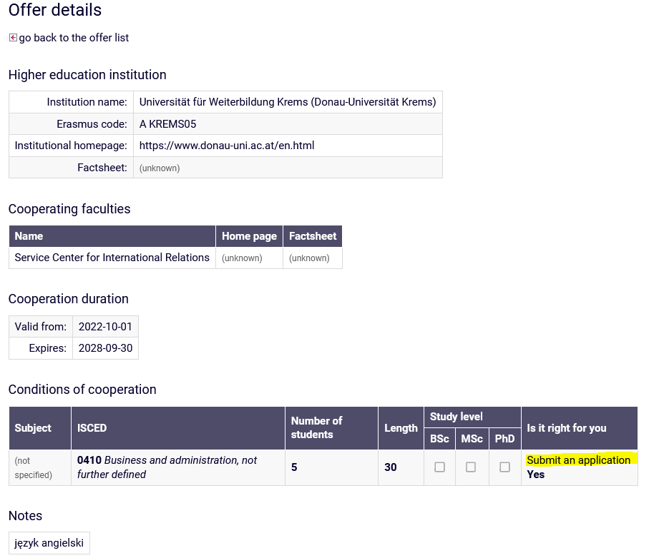

Add another university:

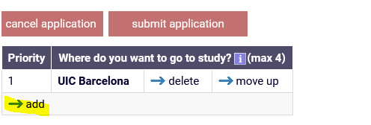

Fill the information about your language skills:

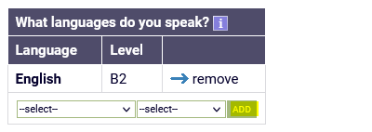

Send the request to prepare the information about your average grades to the Head of the student Service Office:



Here edit and put only dots (…), do not create your CV or motivation letter:

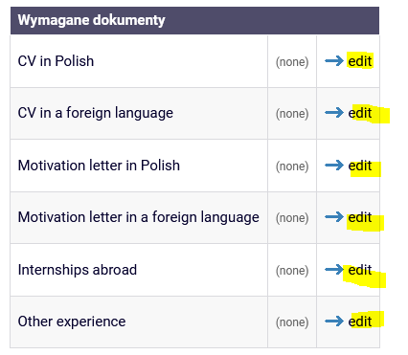

In the field “Other experience” please put information about the semester of planned mobility.

Choose the information about your study program in PUEB

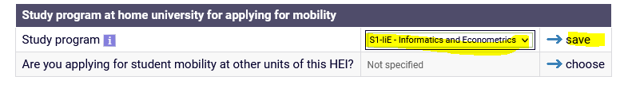

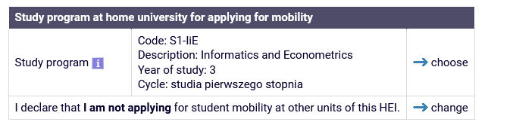

Fill the information about your previous mobility within Erasmus+ program (studies or traineeships) if applicable.

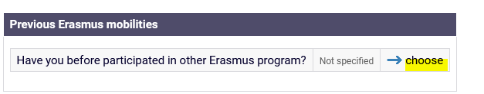

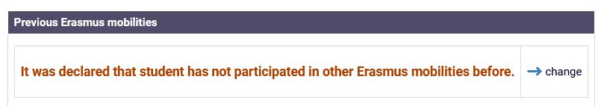

Submit or cancel your application

